**SQL Exercise 3**

1. Display all the Supplier names with the initial letter capital.

1. Display all the Supplier names in upper case.

🡪

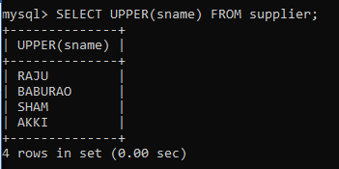

1. Display all the Supplier names in lower case.

🡪

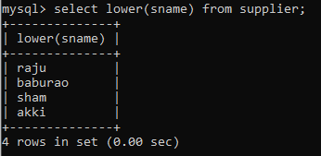

1. Display all the Supplier names padded to 25 characters, with spaces on the left.

🡪

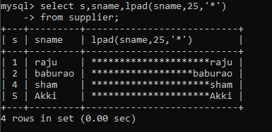

1. Display all the Supplier names (with ‘la’ replaced by ‘ro’).

HINT: REPLACE.

🡪

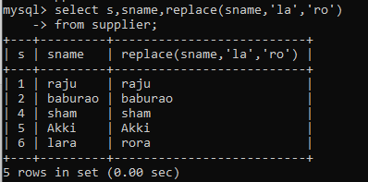

1. Execute the above command with the translate function and note the difference in output.

🡪

1. Display the Supplier names and the lengths of the names.

🡪

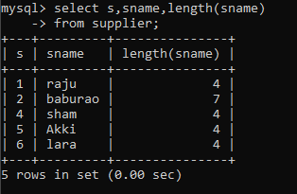

1. Use the soundex function to search for a supplier by the name of ‘BLOKE’

🡪

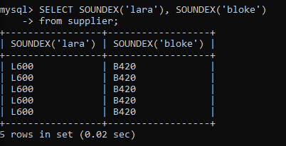

.

1. Display the Supplier name and the status (as Ten, Twenty, Thirty, etc.).

🡪

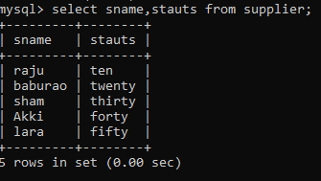

1. Display the current day (e.g. Thursday).

🡪

